# About

This document is to help set up docker as that is where our database will be set up and we will be using docker to create the containerized application.

# Software Requirements for Install

You will need to install some pre-requisite free software on your computer:

1. Docker is required to manage the containers. Installation instructions are here: <https://docs.docker.com/get-docker/>
2. You must allocate at least 1CPU and 4GB of RAM to docker.
   1. Mac: <https://docs.docker.com/docker-for-mac/#resources>
   2. Windows: No configuration Necessary with WSL setup.
   3. Linux/ChromeOS: No Configuration Necessary, but you will need to install docker-compose separately.
3. Azure Data Studio. This is the client tool used to connect to the Microsoft SQL Server and compliments the web equivalents of SQL Pad and Adminer.

<https://docs.microsoft.com/en-us/sql/azure-data-studio/download-azure-data-studio>

# Installing DBMS

To install Learn Databases, clone or download this repository to your computer.

If you have git installed on your computer and wish to clone the repository:

1. Open a terminal window. Make sure you are in a folder where you wish to store the code repository.
2. Type: git clone <https://github.com/mafudge/learn-databases.git>   
   and press ENTER.  
   The code will download from github to your computer.

If you do not have git installed or you do not wish to clone the repository:

1. Click <https://github.com/mafudge/learn-databases/archive/master.zip> to download this repository.
2. After it downloads, unzip the file to a folder where you wish to store the code repository.

Open a terminal in the folder where you installed learn databases and you are ready to go.

# Walkthrough

This video demonstrates how to start, stop and debug the docker environment and connect to Microsoft SQL Server through the Azure Data Studio, SQLPad and Adminer.

[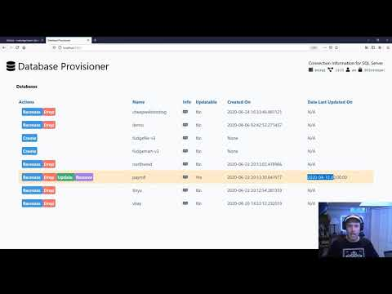](https://www.youtube.com/embed/CxCUrQ6knRo?feature=oembed)

# Commands used in the walkthrough Video

docker-compose up -d

# to start the container/ or bring all the services up

docker-compose ps

# to see the containers are up or down

docker-compose down

# to bring all the containers down

# to stop learn-databases-master_adminer_1 container type the below command

docker-compose stop adminer

# to start database provisioner app

<http://localhost:5000/>